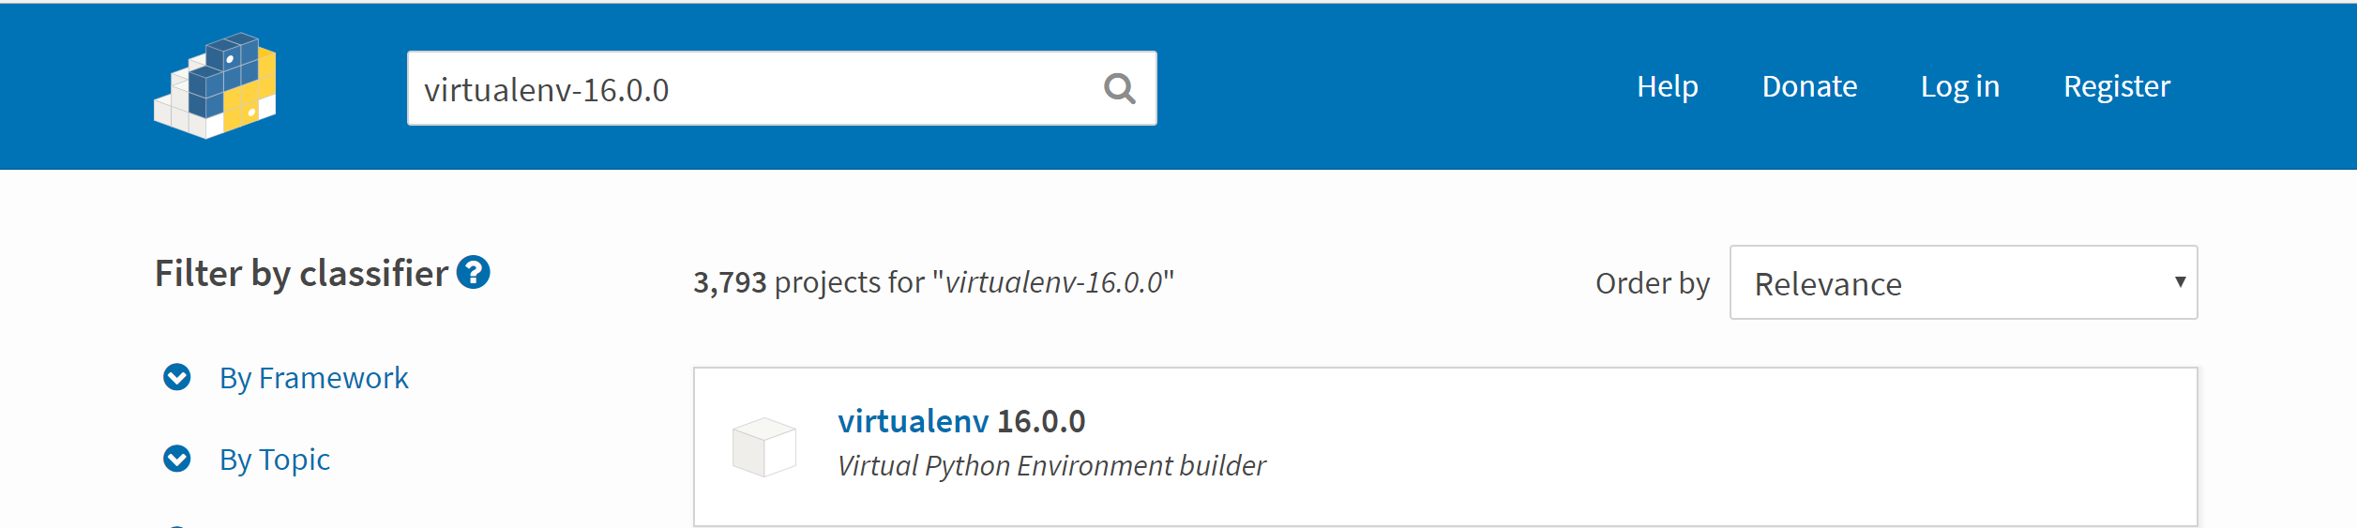





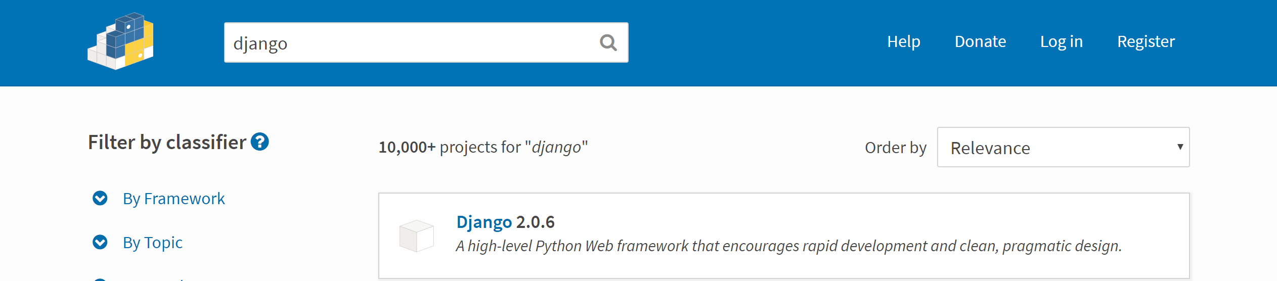

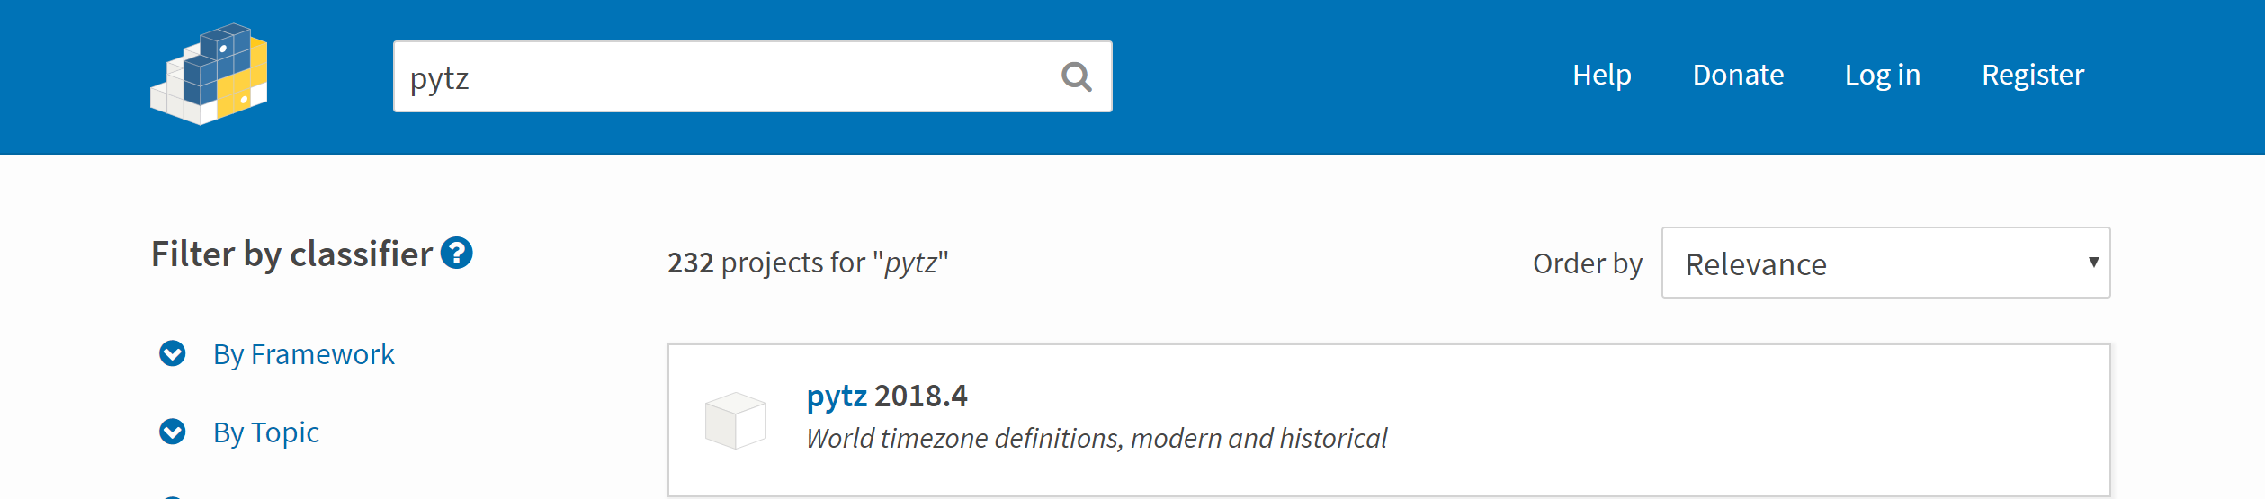



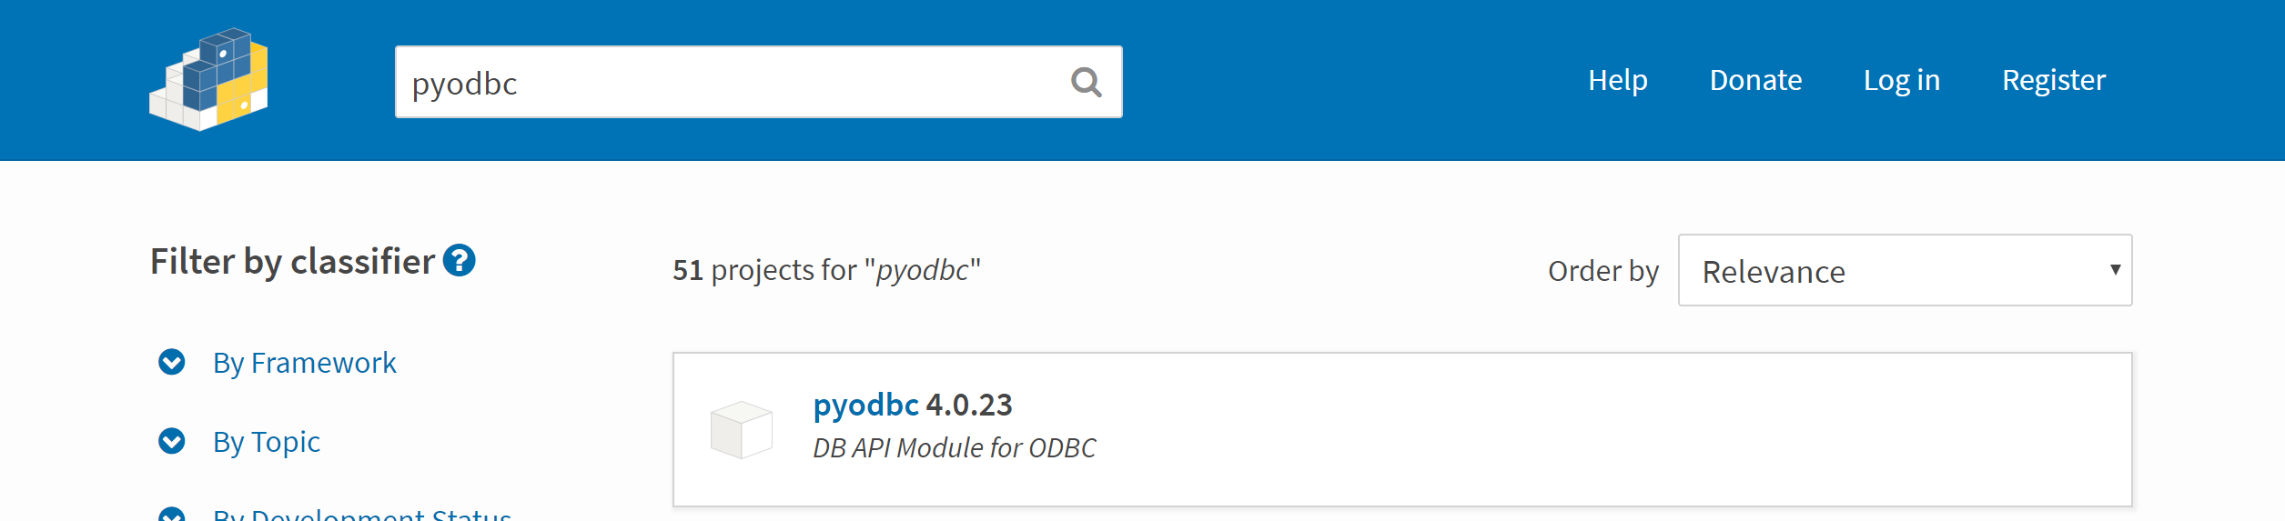



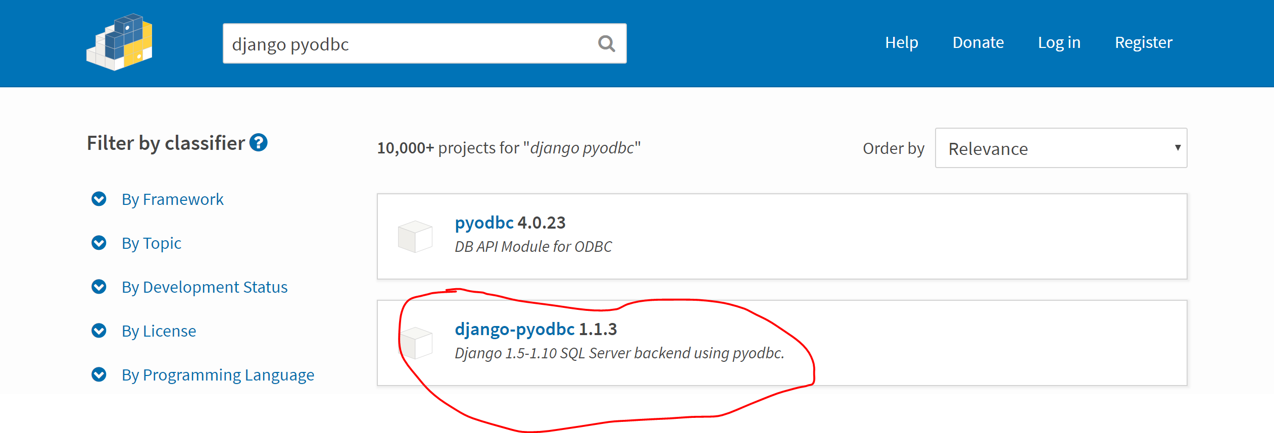



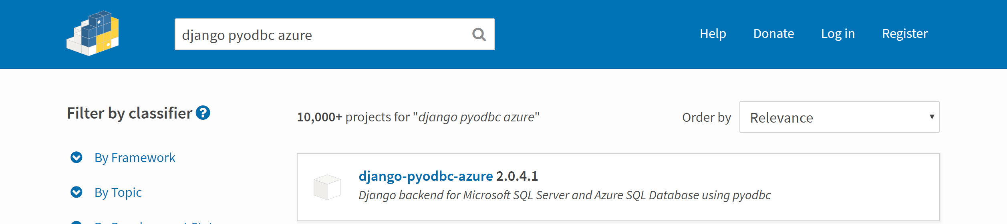

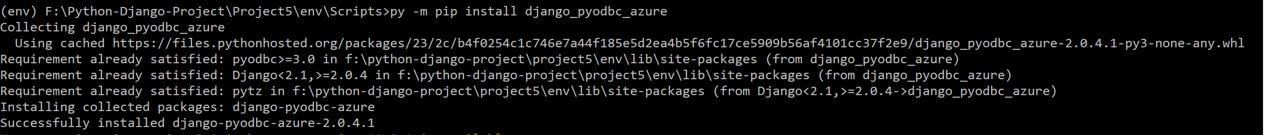





Go to Setting.py

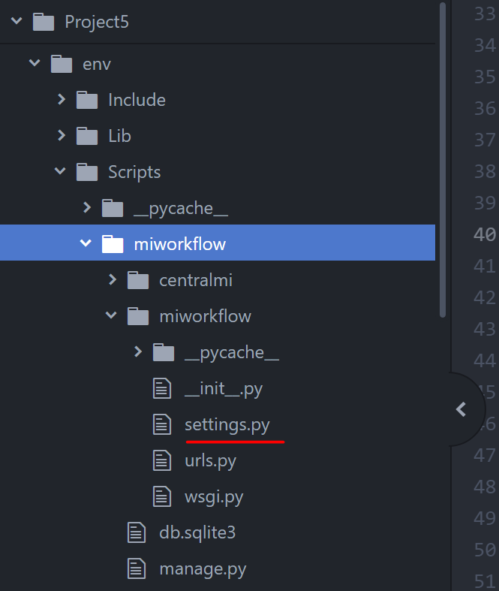

Add app name in installed apps as shown below:

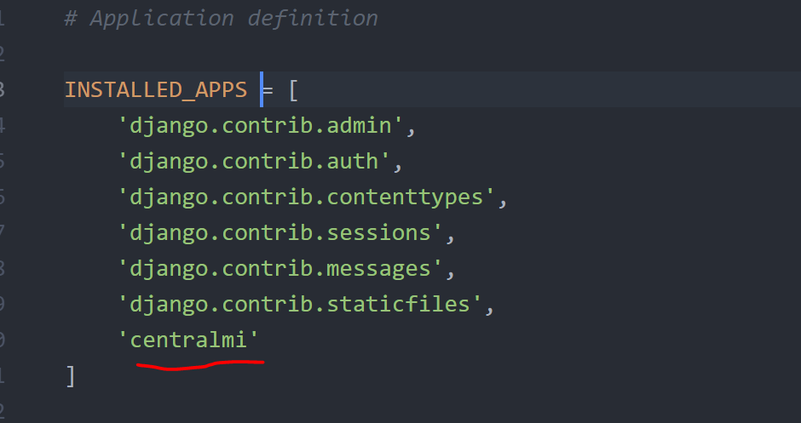

Change database setting as per required mention, I have change the setting to connect SQL Server

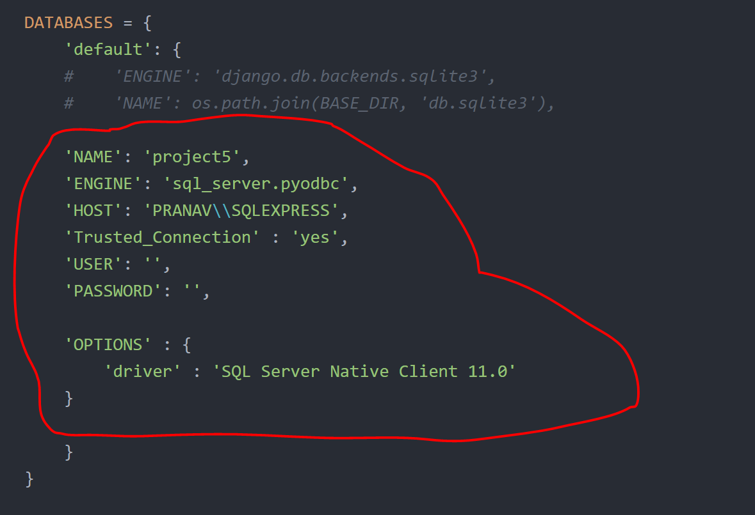

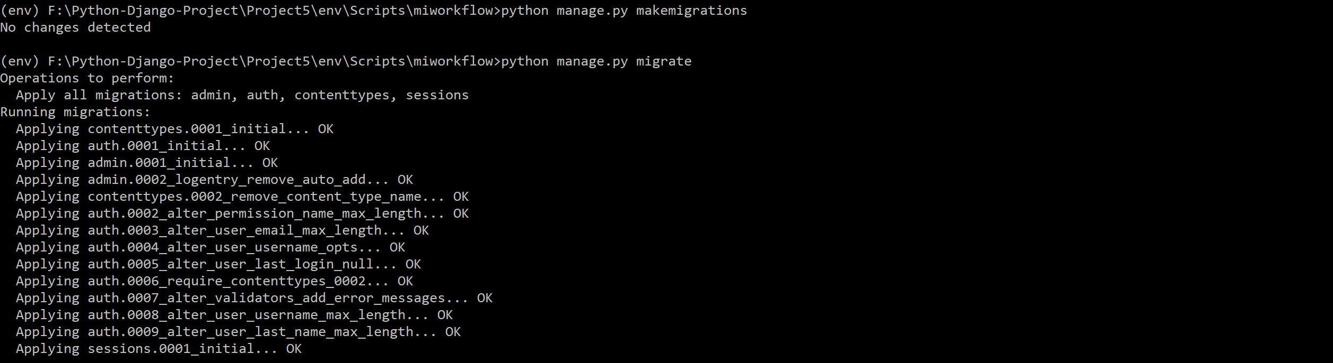

Setup directory for Static file and Templates, create variable for templates and static file as shown below in setting.py

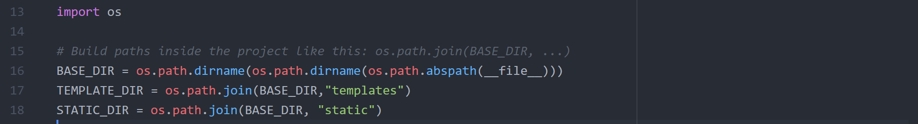

Go to Templates section in Setting.py and specify the ‘TEMPLATE_DIR’ in DIRS

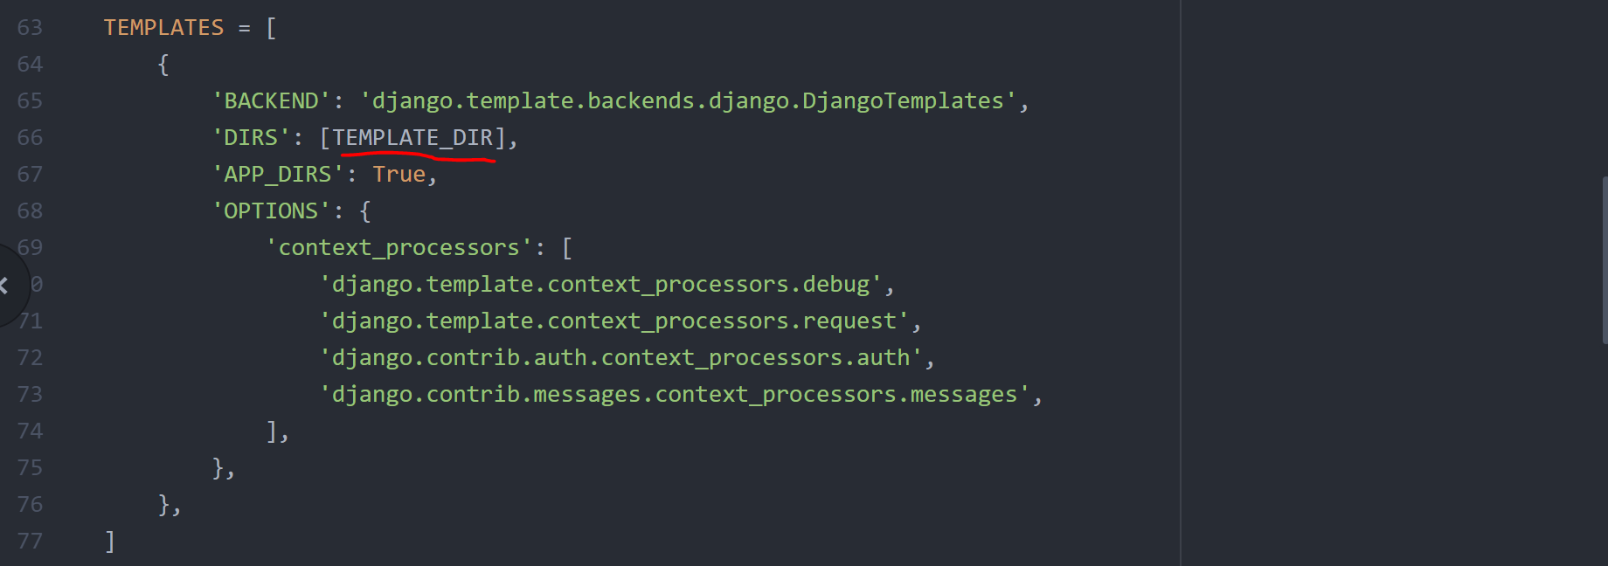

Create Static file root and Media file root

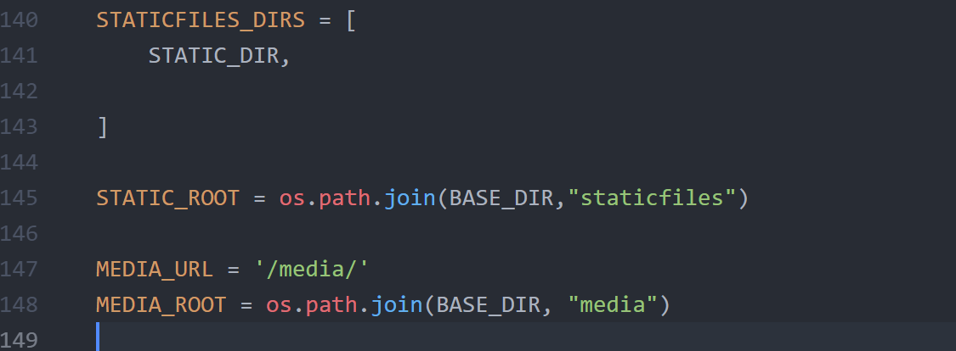

Ref Staticfile and Media file in urls.py

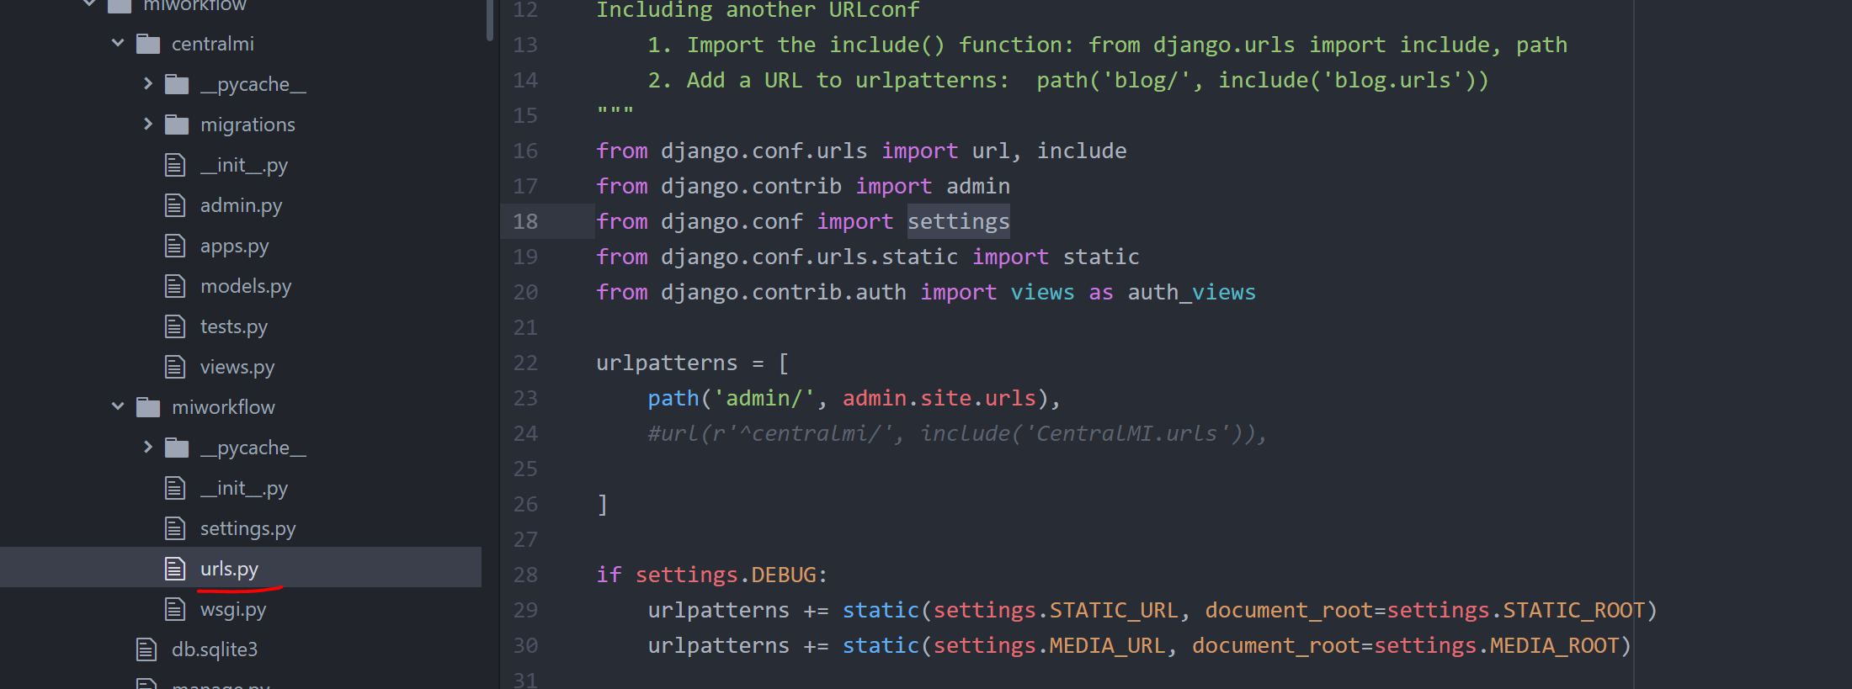

Execute command to collect static files:

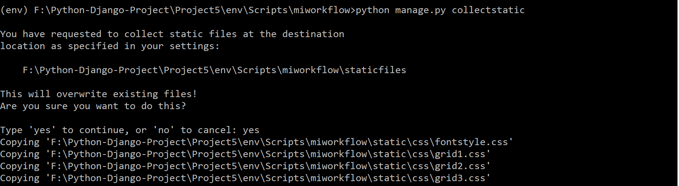

Create urls.py file in app folder and enter the following syntax in it as highlighted below:

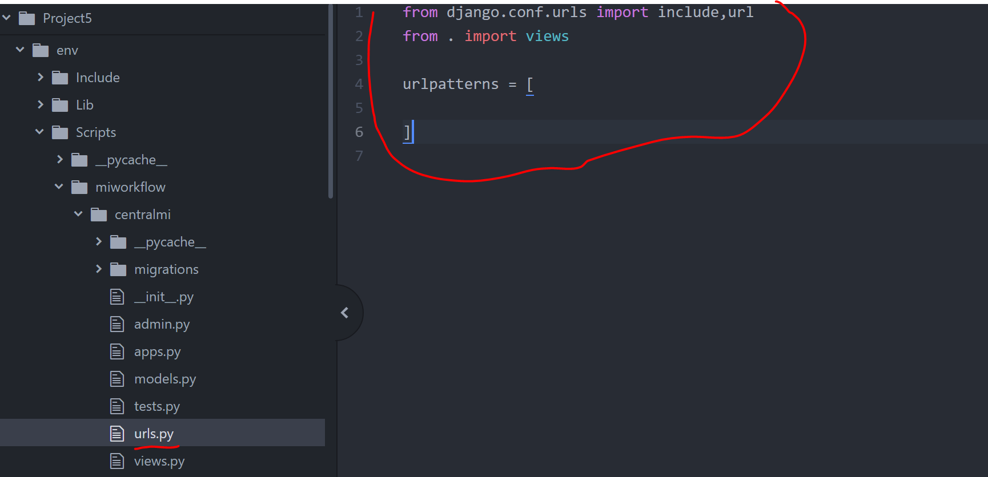

Create table in SQL database, syntax is attached in word:



A file with model1.py got create with above syntax, it is placed in below location.

This file has SQL syntax of model created in SQL server to the syntax required by Django to understand and synchronize

Copy data from model1.py and paste in models.py located in app folder, in the below case centralmi is the app hence go to centralmi folder and paste in models.py

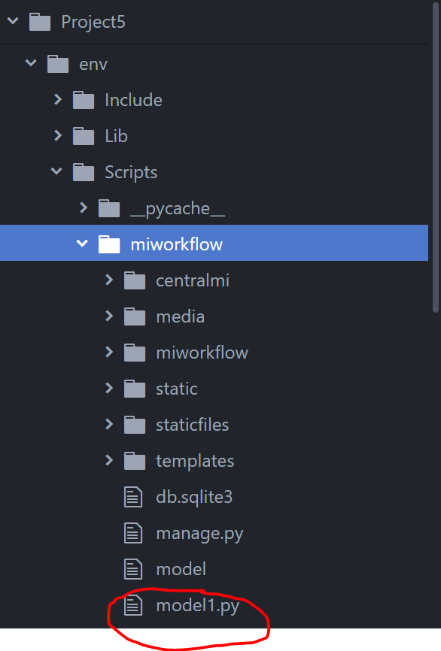 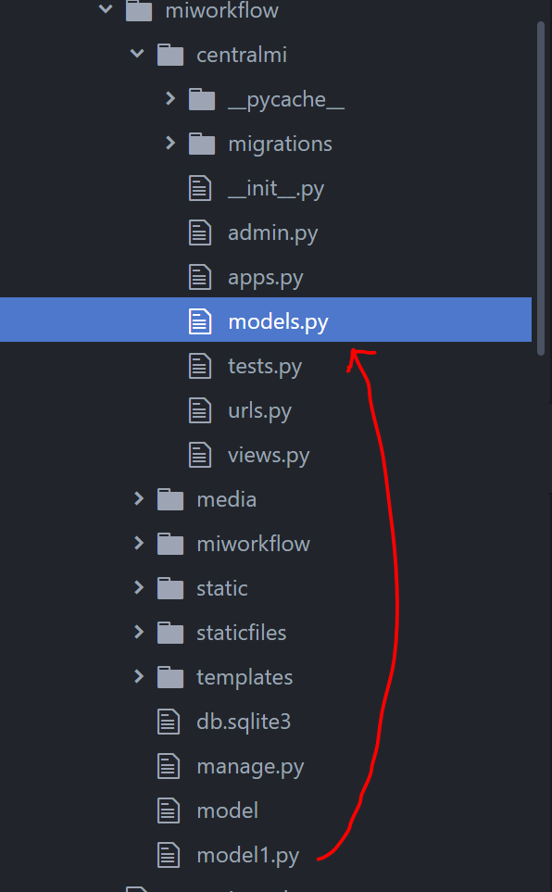

now run command, makemigration, when you run makemigration you will get below error.

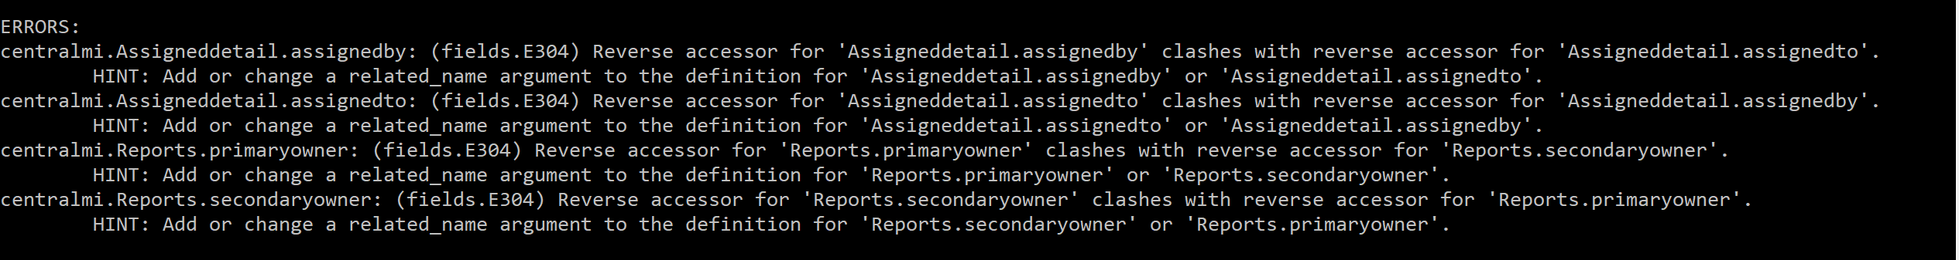

To resolve this you need to add related_name field in the models.py (below is the example).

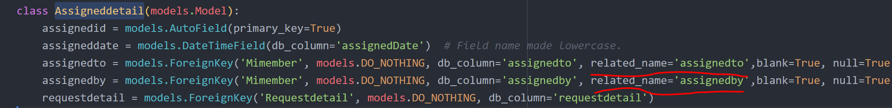

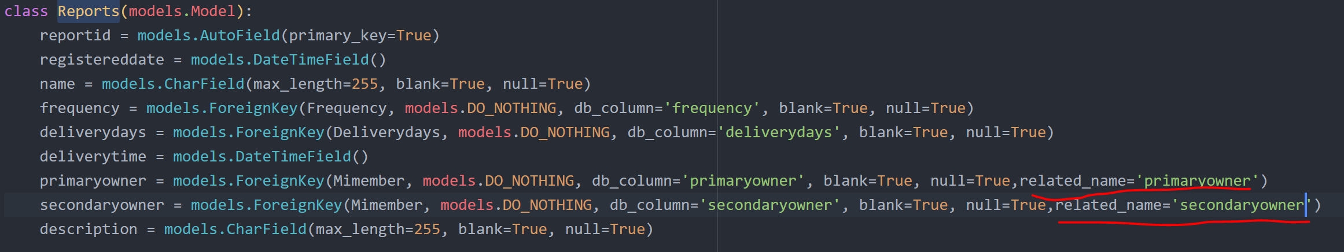

Also add default datetime in datatime field in model, for that import datetime in model

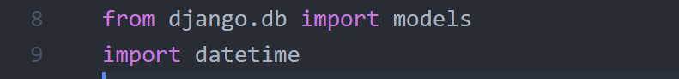

Now add the below highlighted syntax in the field required default datatime.

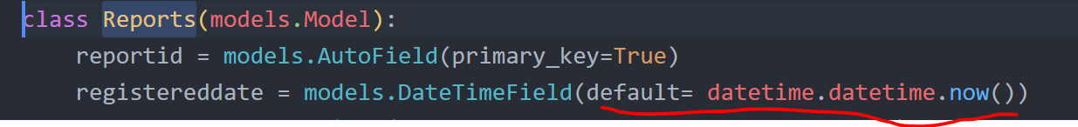

You can find the where we need to add default data time from below attached documents:



After adding above step, once again try to write Makemigrations and migrate command as highlighted below

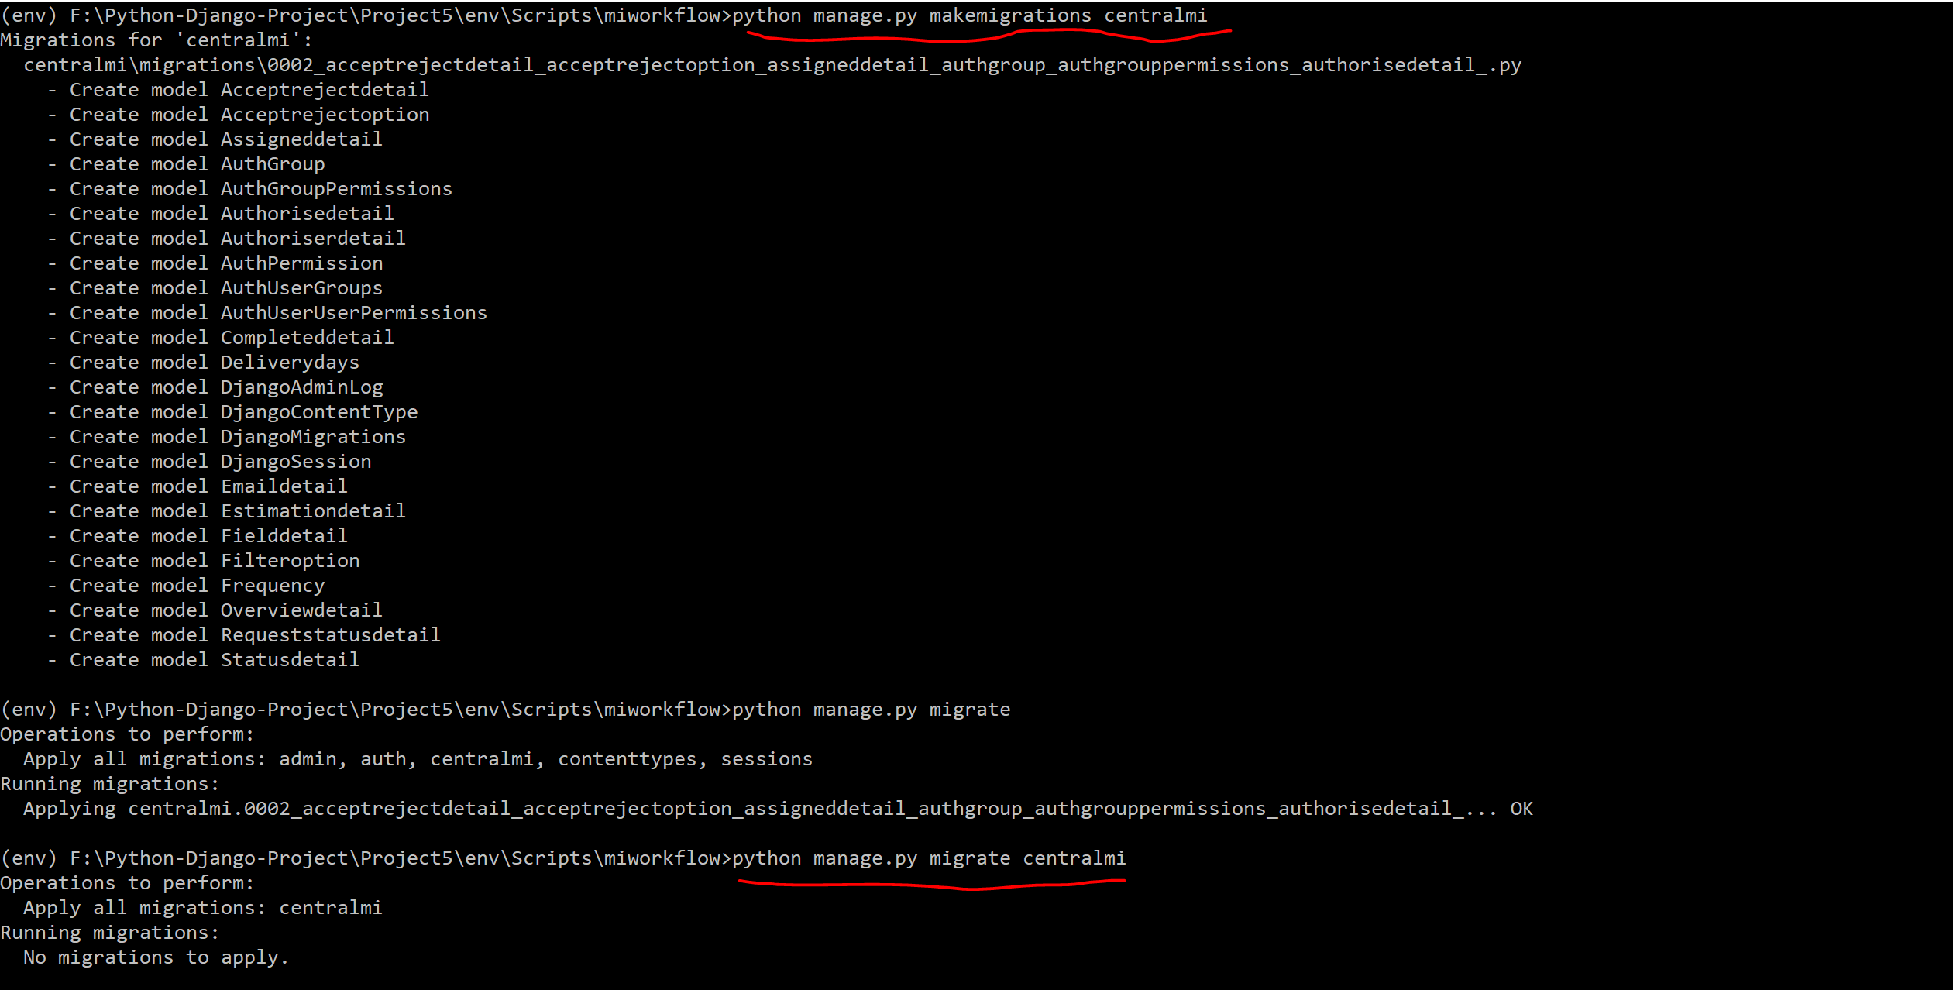

Now register, database in Django admin:



Create Superuser:



Login to admin page as superuser:

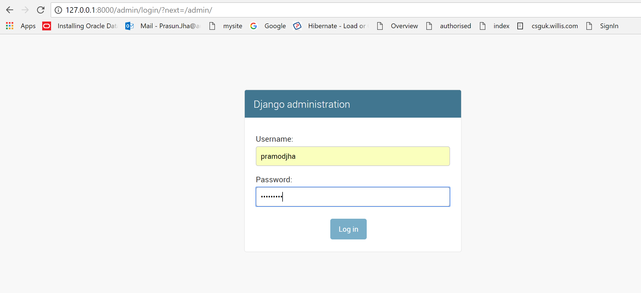

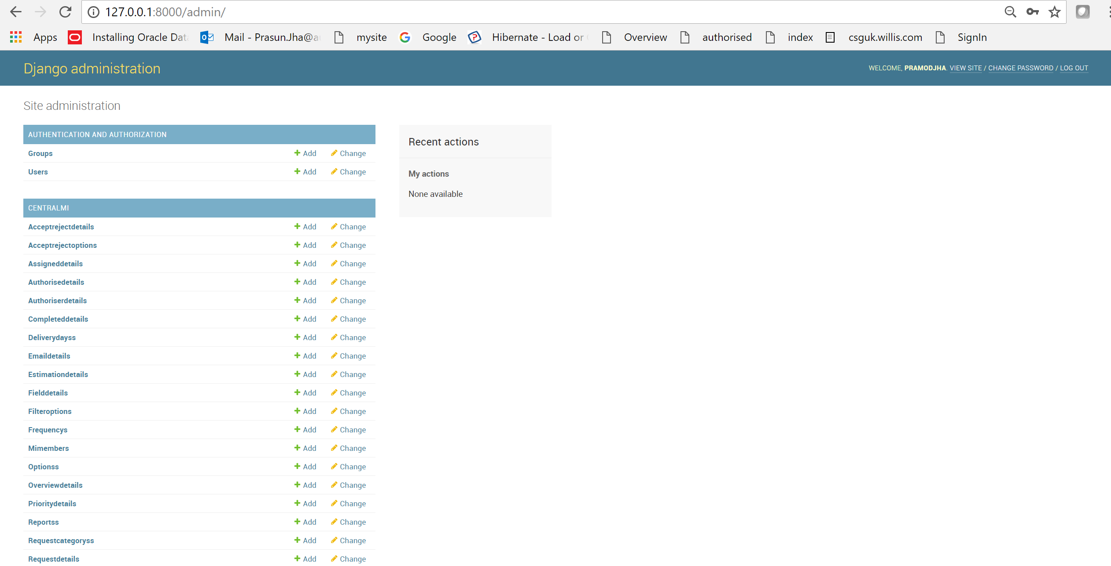

Create group, assign some specific action to the group.

Create user and add them to the group. They will automatically get access to the action assign to group.

Create_model in Model.py

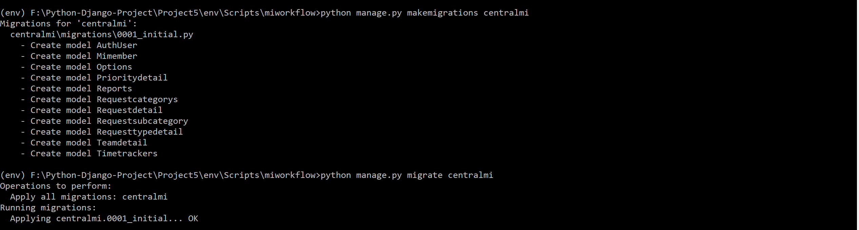

Let’s Customize Django Admin. To customize go to below github save the admin templates and change accordingly and look at this below video link for more:

<https://www.youtube.com/watch?v=dZxEA6Hwr4A>

<https://github.com/django/django/tree/master/django/contrib/admin/templates/admin>

